

**School of Comp. Science**

**Department of Cybernetics**

**GRAPHICS & ANIMATION**

**TOOLS LAB FILE**

**Submitted By Under Guidance of**

**Pranay Gaur Dr. Durgansh Sharma**

**B.Tech CSE-OSSOS Associate Professor**

**500062466 Dept. of Cybernetics**

# Experiment 2

Aim: Design of Logo using GIMP.

Step 1: Open GIMP.

Step 2: Create a new file with 1280 X 1280 px dimensions and rest options to default. Step 3: Add a texture layer by importing some image file.

Step 4: Desaturate that layer.

Step 5: Add a new transparent layer in overlay mode.

Step 6: Select the layer and apply a foreground color of your choice. Step 7: Using blend tool give gradient to the foreground layer.

Step 8: Add text with appropriate font of your choice for the logo. Step 9: Give foreground color to text of your choice.

Step 10: Use blend tool to give gradient to text also.

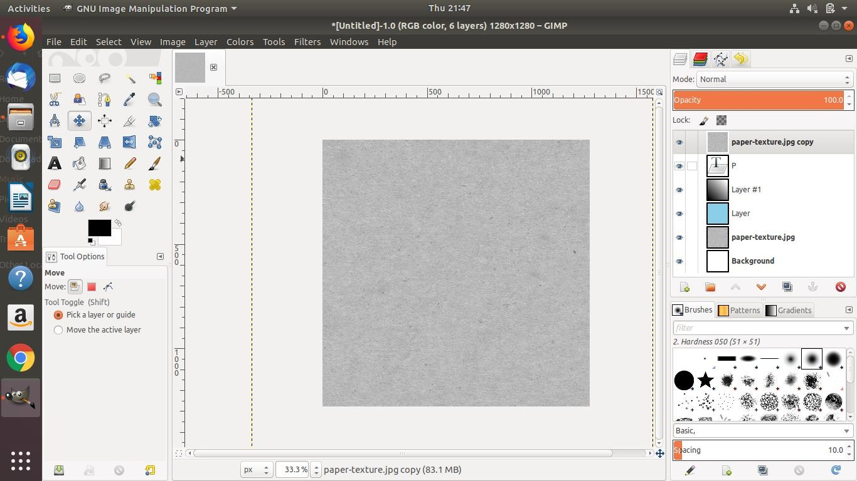

**FIGURE 1: BASE LAYER**

Step 11: Rearrange the layers such that the texture layer and a copy of foreground layer remains on top.

Step 12: Select the top layers and do the alpha selection, then in the selection menu invert the selection and delete the top layer.

Step 13: Merge the top two layers in one.

Step 14: Add a new layer on top, give it a foreground color on black, and set opacity accordingly.

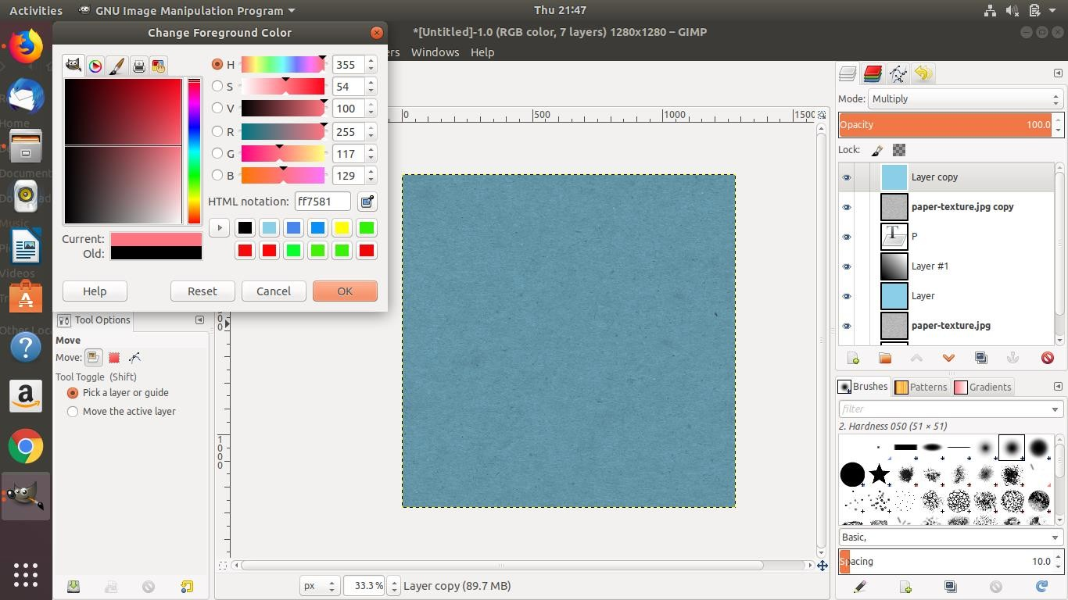

**FIGURE 2: COLORING AND SATURATION**

Step 15: Orient layer’s position accordingly to the text such that it appears as a shadow of the text. Step 16: Do aplha selection on layer, and then go to select do invert and hit delete.

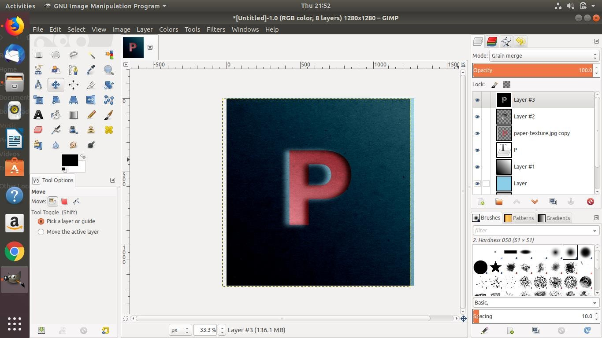

**FIGURE 3: FINAL STATE OF THE LOGO WITH LAYERS**

Step 17: Export image as PNG and save it, final output.



**FIGURE 4: FINAL OUTPUT**